Aim: To develop a Flask Currency Converter Application

Q1. What is Flask and what are its key features?
Flask is a lightweight Python web framework for building web applications.
Key features include:
- Built-in development server
- URL routing
- Template engine (Jinja2)
- Request handling
- Modular design

It's classified as a micro-framework because it keeps core simple but extensible.

Q2. Explain how routing in Flask.
Routing maps URLs to functions using the @app.route() decorator. When a user visits a URL, Flask executes the decorated function and returns the response. Routes can include dynamic variables like <username>.

Q3. What are Flask templates and how does Jinja2 work?
Templates are HTML files with placeholders for dynamic content. Jinja2 enables template inheritance using {% extends %} and {% block %}, and allows inserting variables with {{ }} and logic with {% %} tags.

Q4. How does Flask handle form data from GET/POST requests?
Flask uses the request object to access form data.request.method checks the HTTP method, while request.form['field'] retrieves POST data. GET parameters are accessed via request.args.get().

Q5. How are static files (CSS, JS) managed in Flask?
Static files are stored in the static folder and linked using url_for('static', filename='style.css'). This generates the correct URL path regardless of application location.

Code (app.py):
from flask import Flask, render_template, request

app = Flask(__name__)

exchange_rates = {
'USD': 1.0,
'INR': 92.45,
'GBP': 0.75,
'SAR': 3.75,
'CNY': 6.87
}

def convert_currency(amount, from_currency, to_currency):
if from_currency == to_currency:
return amount

amount_in_usd = amount / exchange_rates[from_currency]
converted_amount = amount_in_usd * exchange_rates[to_currency]

return round(converted_amount, 2)

@app.route('/')
def hello():
return render_template('index.html')

@app.route('/convert', methods=['POST'])
def convert():
try:
amount = float(request.form['amount'])
from_currency = request.form['from_currency']
to_currency = request.form['to_currency']

if from_currency not in exchange_rates or to_currency not in exchange_rates:
return render_template('index.html', error="Invalid currency selected")

result = convert_currency(amount, from_currency, to_currency)

currency_symbols = {
'USD': '$',
'INR': '₹',
'GBP': '£',
'SAR': '﷼',
'CNY': '¥'
}

return render_template('index.html',
result=result,
amount=amount,
from_curr=f"{currency_symbols[from_currency]} {from_currency}",
to_curr=f"{currency_symbols[to_currency]} {to_currency}")

except ValueError:
return render_template('index.html', error="Please enter a valid amount")
except Exception as e:
return render_template('index.html', error=f"An error occurred: {str(e)}")

if __name__ == '__main__':
app.run(debug=True)

Code (root_layout.html):
<!doctype html>
<html lang="en">
<head>
<meta charset="UTF-8" />
<meta name="viewport" content="width=device-width, initial-scale=1.0" />
<title>{% block title %}WEBX EXP 7 | Flask{% endblock %}</title>

<script src="https://cdn.tailwindcss.com"></script>

<link
rel="stylesheet"
href="https://cdnjs.cloudflare.com/ajax/libs/font-awesome/6.5.1/css/all.min.css"
/>
</head>
<body
class="h-screen w-screen bg-gray-100 flex justify-center items-center font-['Segoe_UI','Calibri','Arial',sans-serif] m-0 p-0"
>
<div class="w-[90%] max-w-[600px]">
{% block content %}{% endblock %}
</div>
</body>
</html>

Code (index.html):
{% extends 'layouts/root_layout.html' %}

{% block content %}
<div class="bg-white shadow-lg border border-gray-300 overflow-hidden">

<h1 class="bg-[#217346] text-white text-lg font-medium py-3 px-5 border-b-2 border-[#1e6b3c] flex items-center">
<span class="mr-2 text-xl">📊</span>
Currency Converter
</h1>

<form method="POST" action="{{ url_for('convert') }}" class="p-6 bg-white">
<div class="mb-4">
<label class="block text-[#1e3b2c] text-xl uppercase tracking-wide mb-1">Amount:</label>
<input type="number" name="amount" step="0.01" min="0" required
value="{{ request.form.get('amount', '') }}"
class="w-full px-3 py-2 border border-gray-300 rounded-none text-xl font-[Calibri] bg-white hover:border-[#217346] focus:outline-none focus:border-2 focus:border-[#217346] focus:shadow-inner">
</div>

<div class="mb-4">
<label class="block text-[#1e3b2c] text-xl uppercase tracking-wide mb-1">From:</label>
<select name="from_currency" required
class="w-full px-3 py-2 border border-gray-300 rounded-none text-xl font-[Calibri] bg-white hover:border-[#217346] focus:outline-none focus:border-2 focus:border-[#217346] appearance-none bg-no-repeat bg-right-4"
style="background-image: url('data:image/svg+xml;charset=UTF-8,%3csvg xmlns=\'http://www.w3.org/2000/svg\' viewBox=\'0 0 24 24\' fill=\'%23217346\' width=\'18px\' height=\'18px\'%3e%3cpath d=\'M7 10l5 5 5-5z\'/%3e%3c/svg%3e'); background-position: right 10px center;">
<option value="USD" {% if request.form.get('from_currency') == 'USD' %}selected{% endif %}>US Dollar (USD)</option>
<option value="INR" {% if request.form.get('from_currency') == 'INR' %}selected{% endif %}>Indian Rupee (INR)</option>
<option value="GBP" {% if request.form.get('from_currency') == 'GBP' %}selected{% endif %}>Pound Sterling (GBP)</option>
<option value="SAR" {% if request.form.get('from_currency') == 'SAR' %}selected{% endif %}>Saudi Riyal (SAR)</option>
<option value="CNY" {% if request.form.get('from_currency') == 'CNY' %}selected{% endif %}>Chinese Yuan (CNY)</option>
</select>
</div>

<div class="mb-6">
<label class="block text-[#1e3b2c] text-xl uppercase tracking-wide mb-1">To:</label>
<select name="to_currency" required
class="w-full px-3 py-2 border border-gray-300 rounded-none text-xl font-[Calibri] bg-white hover:border-[#217346] focus:outline-none focus:border-2 focus:border-[#217346] appearance-none bg-no-repeat bg-right-4"
style="background-image: url('data:image/svg+xml;charset=UTF-8,%3csvg xmlns=\'http://www.w3.org/2000/svg\' viewBox=\'0 0 24 24\' fill=\'%23217346\' width=\'18px\' height=\'18px\'%3e%3cpath d=\'M7 10l5 5 5-5z\'/%3e%3c/svg%3e'); background-position: right 10px center;">
<option value="USD" {% if request.form.get('to_currency') == 'USD' %}selected{% endif %}>US Dollar (USD)</option>
<option value="INR" {% if request.form.get('to_currency') == 'INR' %}selected{% endif %}>Indian Rupee (INR)</option>
<option value="GBP" {% if request.form.get('to_currency') == 'GBP' %}selected{% endif %}>Pound Sterling (GBP)</option>
<option value="SAR" {% if request.form.get('to_currency') == 'SAR' %}selected{% endif %}>Saudi Riyal (SAR)</option>
<option value="CNY" {% if request.form.get('to_currency') == 'CNY' %}selected{% endif %}>Chinese Yuan (CNY)</option>
</select>
</div>

<button type="submit"
class="w-full bg-[#217346] text-white border-none py-3 px-5 text-xl uppercase tracking-wide cursor-pointer transition-colors hover:bg-[#1e6b3c] active:bg-[#185a32] rounded-none">
Convert
</button>
</form>

{% if result %}
<div class="mx-6 my-4 p-4 bg-[#e6f0e9] border border-[#bad1c3] border-l-4 border-l-[#217346]">
<h3 class="text-[#1e3b2c] text-xl uppercase tracking-wide mb-2">Result:</h3>
<p class="text-2xl text-[#217346] font-semibold break-words">
{{ amount }} {{ from_curr }} = {{ result }} {{ to_curr }}
</p>
</div>
{% endif %}

{% if error %}
<div class="mx-6 my-4 p-3 bg-red-50 border border-red-600 border-l-4 border-l-red-600">
<p class="text-red-600 text-xl m-0">{{ error }}</p>
</div>
{% endif %}
</div>
{% endblock %}

Output:

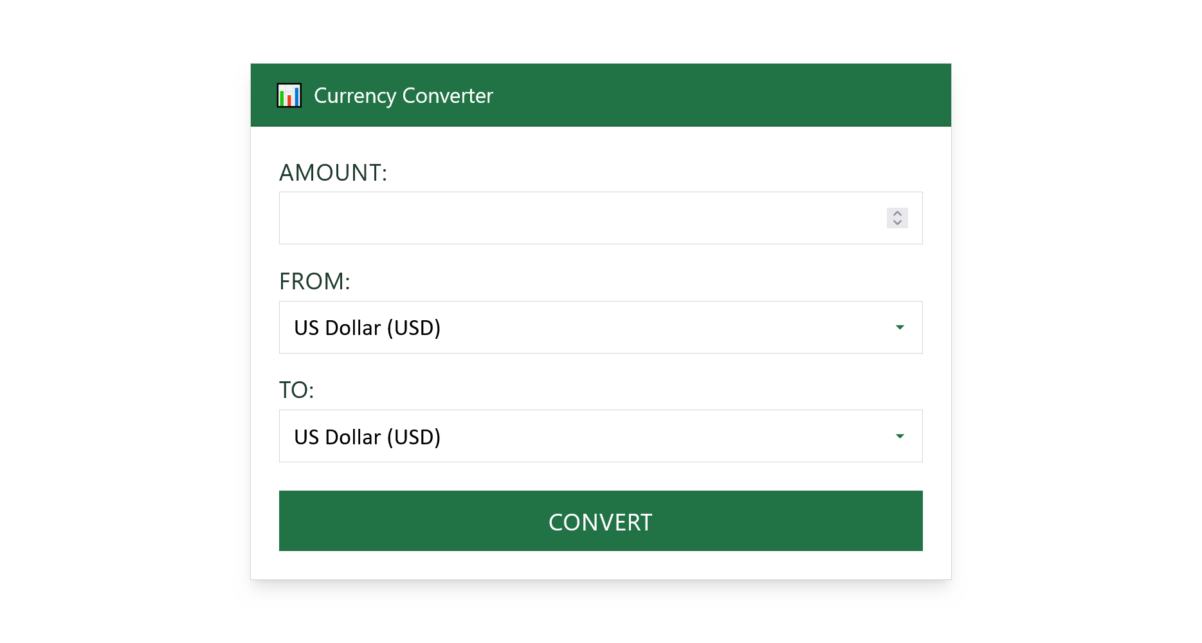

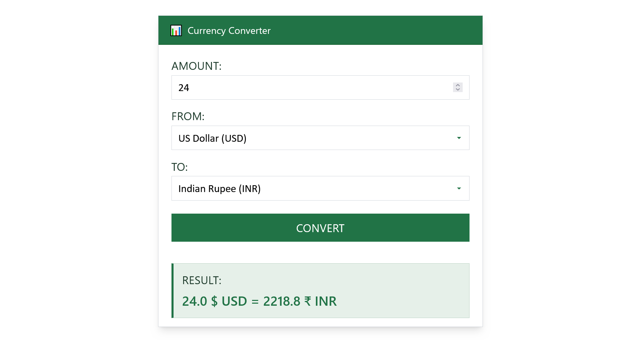

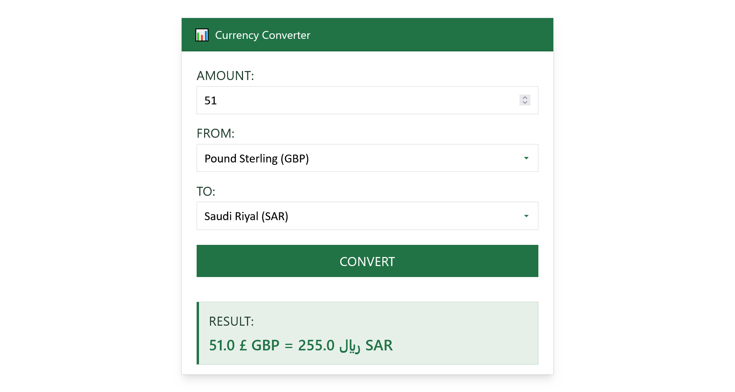

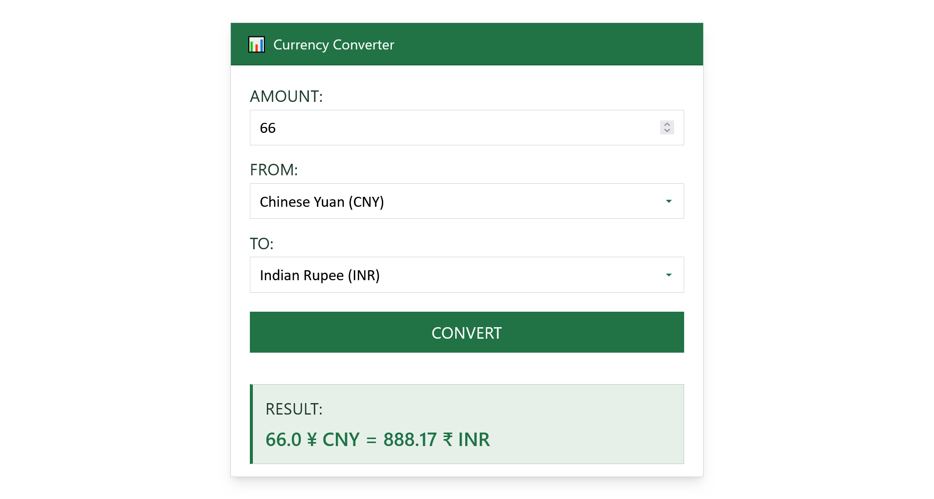

Conclusion:
Successfully implemented a Flask web application demonstrating core framework concepts including routing, templates, form handling, and dynamic content rendering through a functional currency converter.

